FrogCrew

Glossary

Version 1.2

Revision History

| **Date** | **Version** | **Description** | **Author** |
| --- | --- | --- | --- |
| 09/22/2024 | 1.0 | Initial Glossary draft | Kate Bednarz |
| 10/27/24 | 1.1 | Revised all sections and added about 30+ terms | Michala Rogers |
| 01/14/25 | 1.2 | Revised some terms and added some examples | Kate Bednarz |
|  |  |  |  |

Table of Contents

1. Introduction **4**

1.1 Purpose 4

1.2 Scope 4

1.3 References 4

1.4 Sports Broadcasting Relationships 4

1.4 Overview 4

2. Definitions **4**

2.1 Administrator 4

2.2 Crew Members

2.2.1 Paid Freelancers

2.2.2 Paid Students

2.2.3 Students Enrolled in Class 4

2.3 FrogCrew User

2.4 Reports

2.4.1 Report By Name

2.4.2 Report By Crew Position

2.4.3 Financial Report

2.5 Sporting Event 5

Glossary

# Introduction

This document is used to define terminology specific to the problem domain of FrogCrew, explaining terms that may be unfamiliar to the reader of the use-case descriptions or other project documents.

## Purpose

Often, this document can be used as an informal data dictionary, capturing data definitions so that use-case descriptions and other project documents can focus on what the system must do with the information.

## Scope

This glossary is associated with the FrogCrew project, a project to aid in the scheduling of sports broadcasters for TCU Athletics events.

## References

* 1. **Sports Broadcasting Relationships**

Here is a diagram showing the relationships between different roles in sports broadcasting:

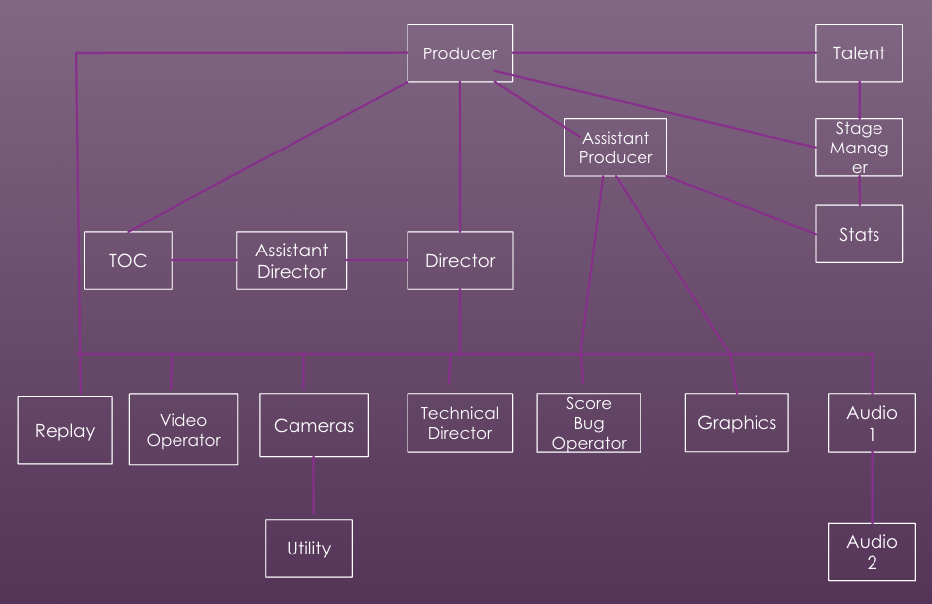

## Overview

The rest of this glossary contains definitions, organized by either stand-alone terms or groups of terms.

# Definitions

The following terms are defined in alphabetical order.

## Administrator

Responsible for uploading game schedules, inviting crew members, scheduling the crew, and sending reports to the crew and the university. They also can edit the crew list as needed.

## Assistant Director

Supports the Director by assisting in overseeing the broadcast operations, often focusing on specific aspects like graphics or timing.

## Assistant Producer

Helps the Producer in coordinating various aspects of the broadcast, including overseeing camera angles, script continuity, and timing of segments.

## Audio A1

The lead audio technician, who is responsible for managing all audio inputs, ensuring clear sound quality, and adjusting audio levels during live broadcasts.

## Audio Assistant A2

Assists the Audio A1 by handling audio equipment setup, troubleshooting, and monitoring specific audio feeds.

## Availability

The set of dates and times when crew members are available to work, which they submit to the system for scheduling purposes.

Availability was initially stored in an Excel document, as shown here:

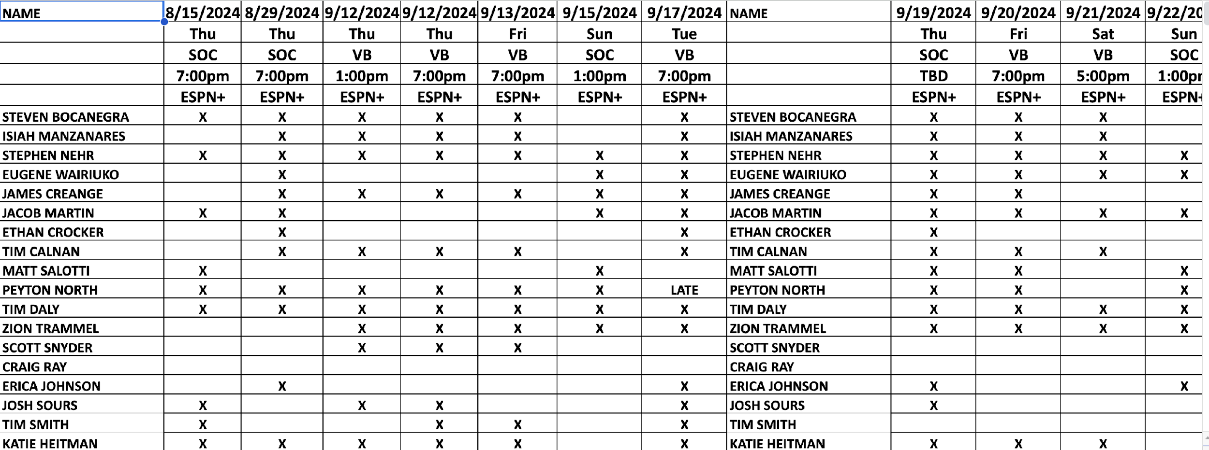

## Bug Operator

Operates the “bug” or on-screen graphics that display the game score, timer, and other relevant information.

## Camera - Fixed

A camera operator who manages a stationary camera that captures a steady view of the game or specific shots, providing consistency during the broadcast.

## Camera - Handheld

An operator of a handheld camera, used for dynamic and mobile shots, often near the action to capture close-up footage.

## Camera - Steadicam

Operates a steadicam, a stabilizing camera system that enables smooth filming even with rapid movements, providing cinematic shots during broadcasts.

## Crew Schedule

An organized list of all scheduled crew members for a particular event, detailing each member’s assigned role and report times.

## Crew Members

### Sports Broadcasters (Students Enrolled in Class)

Students who are required to gain experience in sports broadcasting for class credit. These students provide their availability for TCU sporting events, get scheduled by the Administrator, and work the event. A class that this student might be enrolled in is FTDM 31723: Producing the Live Sports Event.

### Paid Freelancers

Professional sports broadcasters who are paid by the university. These freelancers provide their availability for TCU sporting events, get scheduled by the Administrator, work the event, and then get paid.

### Paid Students

Sports broadcasters enrolled in classes and paid by the university. These students provide their availability for TCU sporting events, get scheduled by the Administrator, work the event, and then get paid.

## Crew List

The finalized list of all scheduled crew members for a particular event, detailing the game date, time, each member’s assigned role, report times, and other specific to the event information. Created and published by the Administrator.

## Director

Leads the live broadcast, calling for specific shots, guiding camera operators, and coordinating the overall flow of the event production.

## Engineer in Charge (EIC)

Responsible for overseeing all technical aspects of the broadcast setup, ensuring equipment functionality and managing on-site technical support.

## ENG 2

An operator who captures footage outside of the main game coverage, typically pre-game or post-game interviews and highlights.

## EVS Replay - Lead

The primary operator of the EVS replay system, responsible for capturing and queuing key moments for replay during the live broadcast.

## EVS Replay - R/O

Supports the EVS Replay - Lead by selecting replays and organizing clips for the broadcast under the Lead's guidance.

* 1. **Finalized**

When a list, schedule, or report is published and unchanging, it can only be done by the Administrator.

## FrogCrew User

## User of the FrogCrew system. To be classified as a FrogCrew user, they must first apply and be approved by the Administrator. They must provide their name, email, phone number, position, and which positions they are qualified to perform.

* 1. **Game**

## A TCU sporting event that requires broadcasting, detailing the date, time, sport, team, and a list of crew members working the event. For example, TCU vs. Utah Men’s Basketball on 1/14/2025 at 7pm crewed by John Smith as Producer, Jane Doe as Technical Director, and so on.

## Game Schedule

A comprehensive schedule of TCU sports events requiring broadcasting, detailing the date, time, sport, team, and network. The Administrator manages and publishes this schedule.

Here is some information provided to the administrator in regards to a game schedule:  
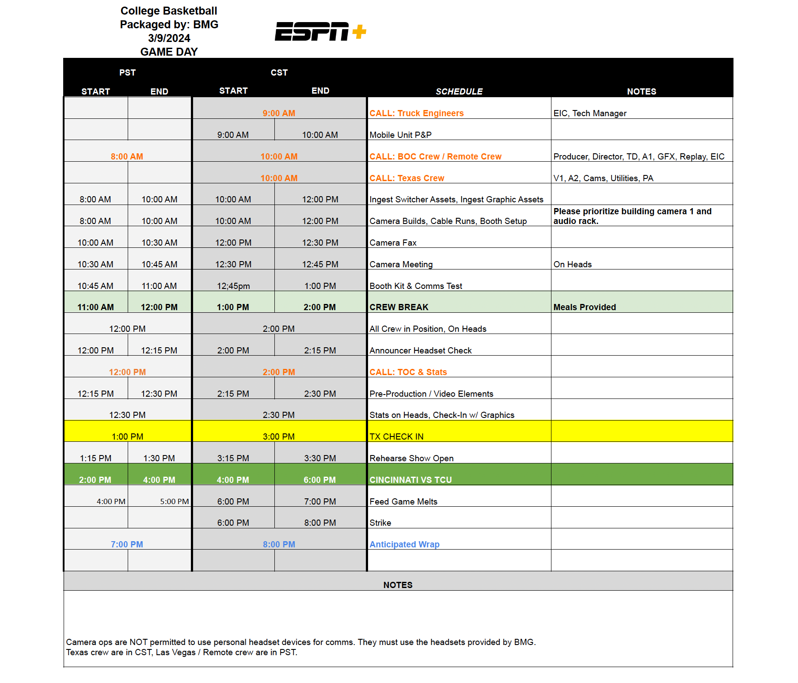

## Graphics Operator

Handles all visual graphics displayed during the broadcast, such as player names, stats, and other visual elements that enhance viewer engagement.

## Producer

Oversees the overall production and ensures all elements, from visuals to timing, are coordinated to create a cohesive broadcast.

## Reports

### Report By Name

A list of all games that a provided name, such as Jane Smith, has been crewed.

### Report By Crew Position

A list of all names that have been crewed by a provided position, such as director.

* + 1. *Financial Report*

A report detailing how much was spent on each game/crew member/position.

## Technical Director

Works closely with the Director to manage the technical aspects of the broadcast, including switching between video feeds and camera angles, and ensuring the technical quality of the broadcast.

## Time Out Coordinator

Manages the timing of breaks, ensuring the production aligns with live game action and scheduled commercials.

## Utility

A general role assisting with various tasks, such as equipment setup, cable management, and support for specific crew roles during the broadcast.

## Video Operator

Monitors and adjusts video quality, ensuring that all visual aspects meet broadcast standards, including color correction and feed stability.

* 1. **Sporting Event**

An event that needs to be crewed using the FrogCrew application. Should hold key information such as date, day of the week, time, sport, team, network, and any additional notes.

* 1. **Submitted**

Information that has been entered and completed in the FrogCrew system by a crew member or administrator for review or processing.

**2.32 Crew List Template**

A collection of positions that are required for a certain type of crew list based on sport.